The 7th National Conference on
Computational Biology and Bioinformatics
NCCBB 2020
11-15, June, 2020

Guidelines for Abstract Preparation

Author One*, Author Two, and Author Three

Department of XXXXXX
University of XXXXX, City, Country
Department of XXXXXX
University of XXXXXX, City, Country
*E-mail: XXX@XXX.XXX.XX

Keywords: Pollution Control; Modelling; Wastewater Treatment.

Abstract

This article serves as the template for extended abstract (1 to 4 pages) for all papers submitted to The 6th National Conference on Computational Biology and Bioinformatics (NCCBB 2019). All extended abstracts will be reviewed. Please use this template when preparing the extended abstract. This will ensure a uniform format in the publication.

The extended abstracts should be written in English, and is to be prepared in Microsoft Word. The two-page extended abstract should include a Title, the information of Author(s) and Affiliation(s), the e-mail address of Corresponding Author, Abstract itself and Keywords. Besides, the use of Equations, Tables, Figures, Acknowledgement, and References are also encouraged. Throughout the extended abstract, use Times New Roman font with single spacing between lines. The recommended font size is 14 pts for the paper title and 11 pts elsewhere. The main text should be justified on both sides. The use of footnotes is discouraged. However, the length of an extended abstract should be at least one page but no longer than 4 A4 pages. Other specific guidelines for each section are given below.

1. Title: Please provide a descriptive title of the paper. The title should be concise and not span more than 2 lines. Use Times New Roman with a font size of 16 pts and in boldface for the title.
2. Authors and Affiliations: Include the first name, middle initial and surnames of all the authors. The name of the corresponding author should be underlined. The affiliations of all the authors should be included. The e-mail of the corresponding author should be shown.
3. Abstract: Use Times New Roman font with a font size of 11 pts for the abstract. The main text should be justified on both sides.
4. Keywords: Provide up to 6 keywords, separated by semi-colons.
5. Equations: The equations should be indented with the numbers displayed on the right side in parenthesis.
S = κ㏑ Ω (1)
6. Tables: The tables should be numbered and captioned (do not use short form for table captions). As a guideline, the extended abstract should not contain more than 2 tables. Please make sure that the tables are not separated in two separate pages. Following is an example for the table.

Table 1: Important Dates for NCCBB 2019
Event | Date
Abstract Submission Deadline: | XXXX
Early-bird Registration Deadline: | XXXX
Regular Registration Deadline: | XXXX
Symposium Date: | XXXX
Filed Excursion: | XXXX

The 9th International Symposium on
Oil and Gas Reservoir Geology and Exploitation
NCCBB 2019
29-31, Mar., 2019

- Figures: The figures should be numbered and captioned (use “Figure 1” in text). It is recommended that the figures be produced in gray -scale and has at least 300 dpi. As a guideline, the abstract should not contain more than 2 figures. No color graphics are possible in the Book of Abstracts. For sketched figures, it is best to be included in the Drawing Canvas of MS Word (Insert/Picture/New Drawing). A sample is given as follows.

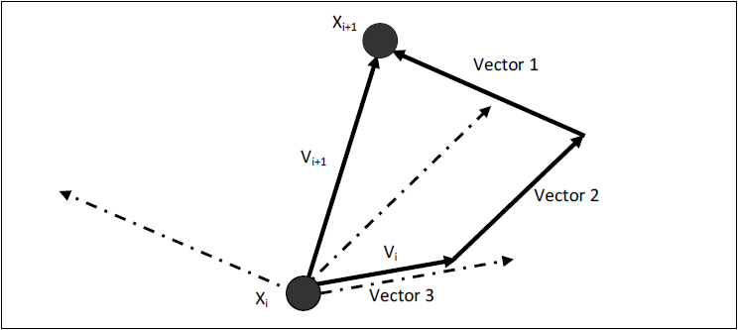
Figure 1: The Drawing Canvas

- Acknowledgements: Any acknowledgements can be included at the end of the main body of the extended abstract but before the references.
- Citations and References: In the text, refer to literature citations in the author-year format, e.g. [Author, 2006] or [Author1 and Author2, 2007] or [Author 1 et al., 2008]. The references should be placed at the end of the extended abstract in the alphabetical order.

Acknowledgement: The authors thank the Ministry of Science, Technology and Innovation for the Science Fund project of XXXXX.

References
Krauter, S., Ruther, R., 2004. Considerations for the Calculation of Greenhouse Gas Reductions by Photovoltaic Solar Energy. Renewable Energy. 29 (3): 345-355.
Moller, B. F., Assadi, M., Potts, I., 2006. CO2 Free power generation in combined cycles – integration of post -combustion separation of carbon dioxide in the steam cycle. Energy. 31, 1520th-1532.
Perry, R. H. and Green D. W. (Eds.), 1997. Perry’s Chemical Engineers’ Handbook. 7 Edition. New York: McGraw Hill.
Soo, S. S. T., Toh, E. L., Yap, K. K. K., Ng, D. K. S. and Foo D. C. Y. (2010). Targeting for Minimum Flowrate for Multiple Treatment Processes, paper presented in 1 International Congress on Process Engineering and Advanced Materials (ICPEAM2010), Kuala Lumpur.

